Classroom Newsletter

School Fundraising

Cookie Kits

Food Truck Day

Make-A-Mascot Kits

May 2023

The Larana Elementary School

For the last month, our school has been doing several events for the "School Fundraising" agenda. All of the school members – students, teachers, and parents – have been working with various parties.

A collaboration with a local bakery to sell kits, such as baked sugar cookies and decorating items (icings, sprinkles, etc.) in various colors. We tried to decorate them with our school colors or mascot.

Working together with several local food trucks to park at the school one day, from brunch to dinner time.

Friendly cooperation with a toy company to sell everything the kids need to make a stuffed animal. We chose a teddy bear, designed with our school mascot.

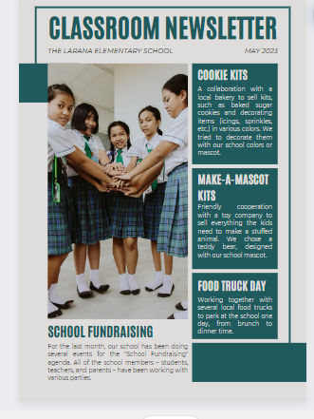

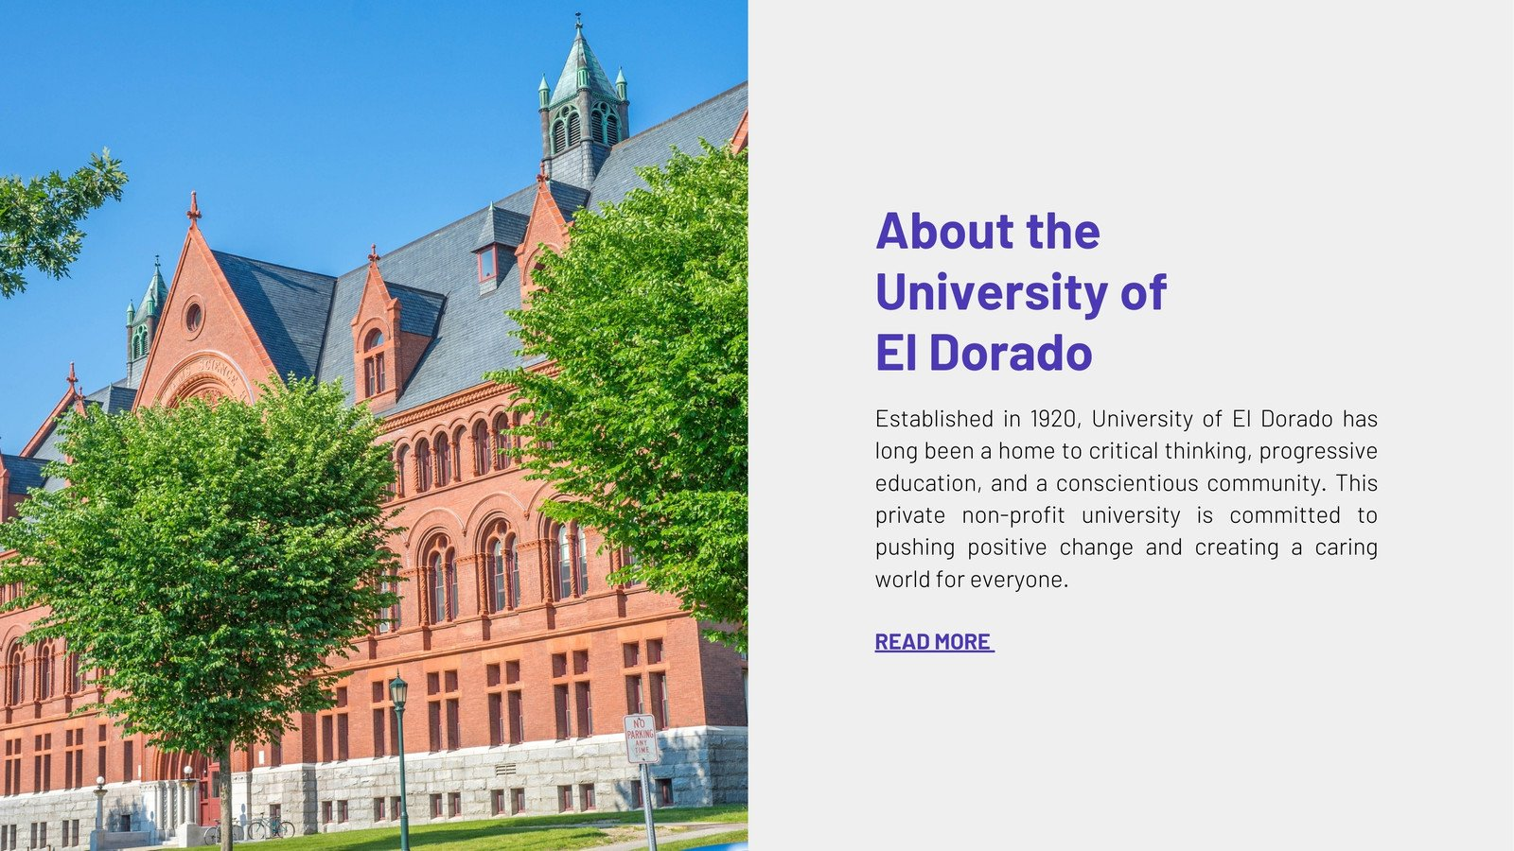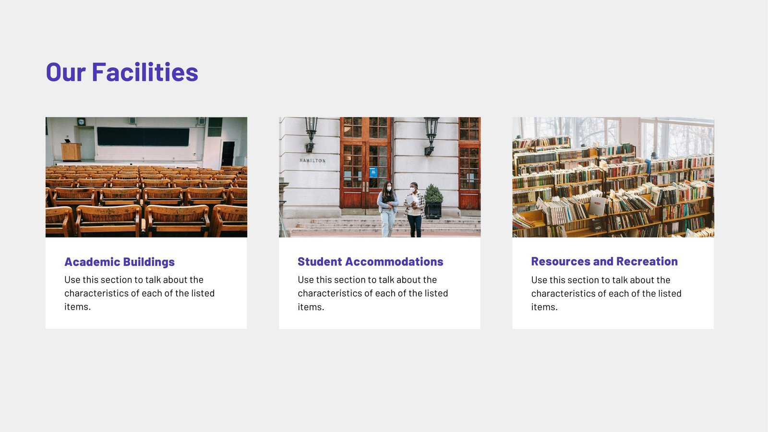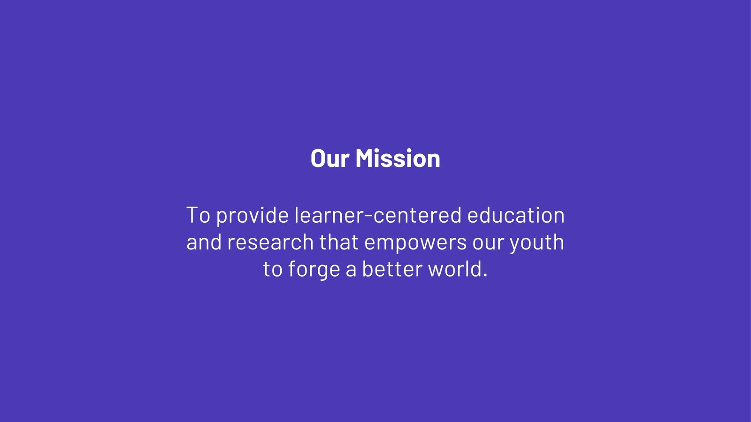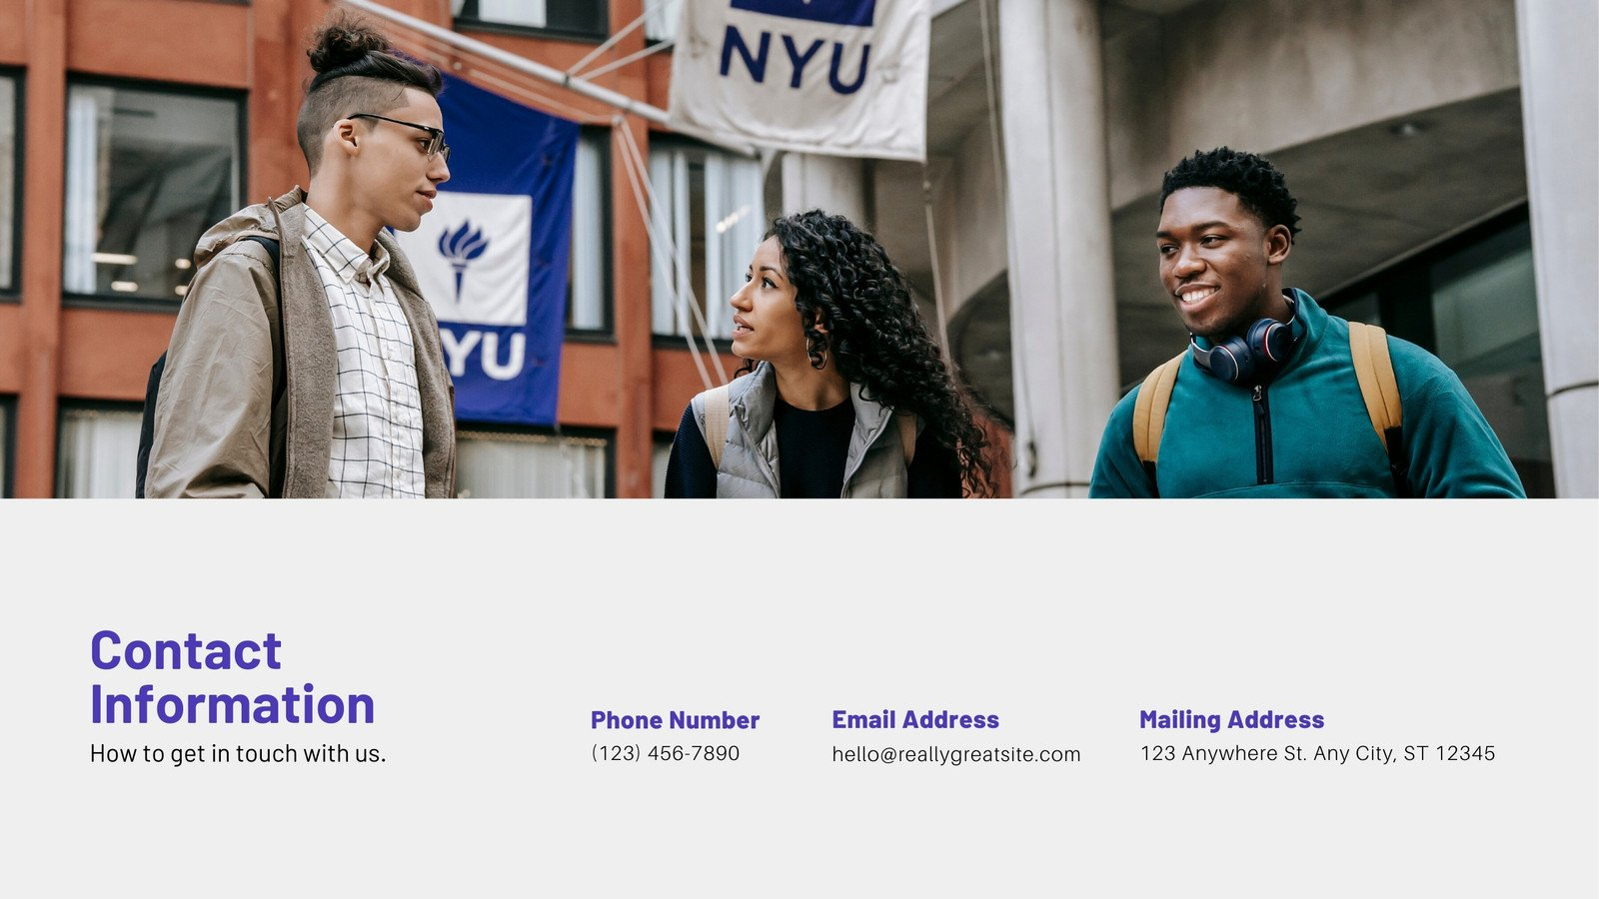

**White and Purple Photographic Education Non-Profit Website**

Website • 1366 × 768 px

[**Customize this template(opens in a new tab or window)**](https://www.canva.com/design?create&type=TAEXfxtKgiU&template=EAEvHZ7Vges&category=tAEW8R8e5hc&analyticsCorrelationId=4f077d63-d270-413a-aa73-5f5d61cb0d4a&schema=web-2)

**More like this**